# Sun Shader 1.3.0 Manual

Designed by Panteleymonov Aleksandr 2017

## About

It is a simple procedural generator of sun of some rays star. The peculiarity of the use of this Shader is completely generated by the content without using additional resources. But the full synthesis is a demanding task, also added a variant using static synthesized 3D texture. It is available only for the Pro version of unity 4. Full functionality is available for Unity5. Also now available the shader uses a 2D texture and a shader allows to reproduce the stored animation in the texture for better performance.

## How to use

A quick way to create a model using a Shader to apply the script to an empty GameObject "Component/Space/Star/SunGenerator”. You can also use any of the materials in Examples on any object appropriate for the parameters of radius. For the completely manual creation use the appropriate Shader "Space/Star" while creating material.

In any case the model is created you can see a set of options which can be fully customized to feature your visual stars.

### Mode Shader

Specifies the Shader model to be used to generate the stars.

* SM4 - is a fully synthesized the star in real time, requires a lot of resources performance.
* SM3 - a simplified model for low-end devices, but also requires a lot of resources performance.
* CPU_SM4 - version with low resource consumption using static texture. require support sampler3D
* CPU_SM3 - for low-end devices, uses a static texture, require support sampler3D
* CPU_2SM3 - for low-end devices, uses a static texture, no require.
* LIGHT_SM4 - it is a simplified version of the Shader rays and body which are synthesized together.
* LIGHT_SM3 - an even more simplified light version.
* LIGHT_CPU - also option allowing to use a texture synthesis noise. require support sampler3D

### Mesh Type

This is an automatically generated surface on which to display the object. Really, you can use the surface of any shape, but in proportion to the total radius of the object.

* Billboard – simple surface allows you to display the model star at a great distance from the camera. If you place an object too close the edges will be cut.



* Prisma - more complicated surface covering the visual range of the Star.

If you use any non-standard surface such as a cylinder, without using a script - using the material, you will notice that it will automatically rotate to the camera, and all of its basic geometry settings will be reset, in addition to Transform-Scale, so you can set it to the desired size.



### Radius, Ray String and Zoom

Three parameters specify the relative dimension of the model. Their combination allows you to set the basic shape.

* Radius sets the amount of material mass of the star.
* Combination with Zoom will allow you to increase or decrease the number of parts.
* Ray String - the space around the stars covered by the rays.

From left to right: big Ray String, all Medium, big Radius.



You will notice that if you increase the Radius and decrease the Zoom on the surface, there will be more details, but the overall size will not be changed.

### Detail and Seed

Depending on model the Shader quality of detail can vary. The basic range is from 1 to 6. If you use 0 it will be black hole.



Seed – the uniqueness of the model was generated.

### Glow, Rays, Ray Ring and Ray Glow

The four parameters specifying the glow around the body of the star.

* Glow is the intensity of illumination around the body, 0 is a reasonable maximum, but you can use negative values.
* Rays - sets the contrast of the rays at the surface, also negative values make a big contrast.



* Ray Glow also sets the contrast of the rays but at the end of the rays.
* Ray Ring - creates a beam of rays.



### Colors

Four colors define the surface, and two rays.

* Light - is the most vivid color of the surface.
* Color - is the primary color.
* Base color - the color of the soil.
* Dark color - the cooling elements.
* Ray Light - color illumination rays.
* Ray Color - color of rays.

### Animation

You can set the animation speed of certain elements.

* Speed Low - is the speed the smallest detail which can only be seen at very high quality.
* Speed Hig - is the speed of the main body elements of the star.
* Speed Ray - specifies the jitter radiation.
* Speed Ring - speed bursts of rays.

### Noise Generator

The construction of the surface of the object and rays is based on a combination of several noise fields. Each field is a layer of detail which is set with its brightness and scale of elements. Each implementation has a different number of layers, which are divided into four groups, for which you can set their parameters. To the surface of the object is set to the brightness and scale, for the rays the scale.

For example you can take any noised image, and zoom it on 800%, 400%, 200% and 100% in any image editor like photoshop.

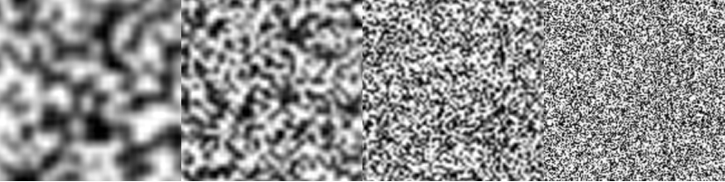

This would be equivalent to Body Noise Scale (1.0, 2.0, 4.0, 8.0). But if you fold these layers the result will be overexposed. Now if you set the brightness for each layer to 25%, Body Noise Light (0.15, 0.15, 0.15, 0.15). When adding such images will get the result:

 

While experimenting with the brightness you can get more expressive form Body Noise Light (0.05, 0.1, 0.25, 0.3):

 

This is the basis for modeling the object's surface, For modeling rays brightness is settable control elements (Rays, Ray Ring and Ray Glow), this is only used scaling layers. The equivalent proportions for the rays Ray Noise Scale (1.0, 2.0, 2.0, 2.0)

### Save generated materials

A small set of tools which will allow you to simplify working with shaders and create using their own materials. The first is the saving and loading parameters of the generator by means of XML files are only available for editor mode. To do this, use the button "Load Template" and "Save Template". Also in the folder "Asset/SunShader/Templates" is the starting set of templates which you can load and use at your discretion.



After you select the satisfying generator settings you can save the resulting material in the "mat" file using the button "Save material" and use it on any other geometry or object. In order to be able to use stored material as well as when using the generator use "SunShape" component. It is designed to generate a surface satisfying the material parameters, such as Radius and Zoom, and is available in the branch menu "Component/Space/Star/SunShape”.

You will not be able to save the material based shaders use textures as they will not work correctly without texture. But you can save the animated texture for use in a special shader. To do this, use the dialog box "Save animated".

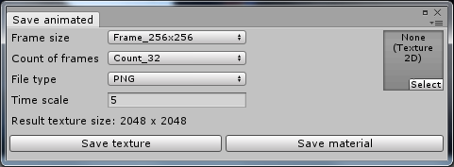

First you need to create a texture that will be used in the material. Here you can choose the frame size and total number of frames for animation save. Below you can see the total size of textures that work with your chosen parameters. As to uniformly cover the surface of the sphere was used two frames, the total number of individual frames in half. It is necessary that your editor is correctly supported compute shaders otherwise you may have problems with this feature in Unity 4.0.

After you save the texture on the button "Save texture" frame is filled with a texture2d, it will be used for the creation of the material. You can use another stored texture, but it can lead to undefined results. Depending on Sader Model will use the corresponding Shader in the creation of the material. "Sun_soft_animated" for Ligth model and "Sun_animated" for other. You can also use the "SunShape" component with the received material.

If there are problems with the speed of the animation you can use the parameters Time Scale in this form and the Speed parameter in the resulting material for calibration. Time Scale will help you to skip unnecessary frames if the original animation was too slow, and Speed equalize speed after the creation of the material.

## Star Spase Generator

Addition to create a skybox allows you to build the environment of the scenes in the selected quality as space. You can create 6 textures for the cubemap and also to make the material based on the "6 Side" shader.

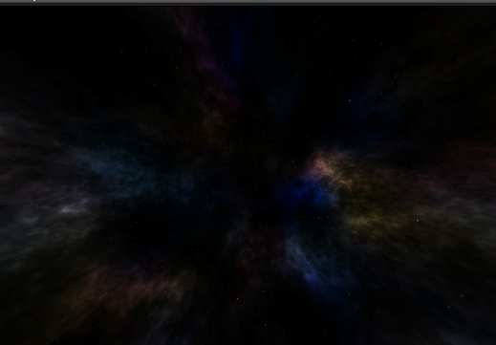 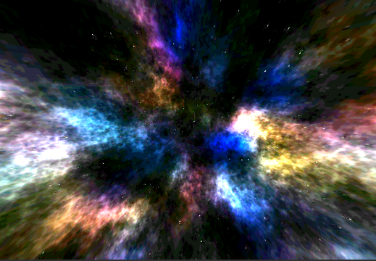

The generation process is quite simple and does not have enough of the original effect but you can try to experiment with colors and form nebulae. Select the scene camera and add the "Star Space Generator" component in the "Component / Space / SkyBox / StarSpaceGenerator" menu.

### Stars

Stars consist of two levels, each of them, you can set brightness settings “Stars Bright Primary” and “Stars Bright Second”. The color of the stars is defined by three parameters, two colors specify the color around the stars, and the third "Stars Primary" is the primary color inside each star. The second layer of stars uses only the primary color.

### Clouds

Clouds allow us to create a kind of cosmic nebula. They consist of two algorithms for the noise of Perlin and the Voronoi diogram. These multi-layer algorithms each layer is modeled by two parameters.

* Light Stage - intensity of each of the following layer noise
* Scale Stage - scale of each of the following layer noise
* Voronoi Perlin - interpolation between the two noise algorithms "Voronoi" and "Perlin".

Additional parameters "Zoom" and "Bright" set overall scale and the brightness of the nebulae. The color of the clouds is formed by blending two colors with the main one.

### Material properties and save.

Building a Skybox can be performed by two methods is indicated by the parameter "Update type".

* Manual - генерация происходит по нажатию клавиши "Update". выполняется при помощи compude shader. In this case, create 6 textures.
* Real Time - for building a material with the Shader that builds the image dynamically, allowing you to display any changes. But this leads to poor performance.

The other two parameters are used only to preview the result.

* Texture Size - sets the size of textures to be used in "Manual" mode and when saving them.
* Exposure - effect emulation of the brightness of the image dependent on the radius of the diaphragm. Only for viewing.

Now we can save textures for a Skybox and to create material or cubmap. To do this, use the button "Save Sky Box" and fill in the appropriate parameters.

* Spacer – the type of separator between the file name and the indicator face of cubemap.
* Name prefix – type of indicator face of cubemap.
* File type - the file format for textures.

Then choice the file name for the material on the button "select". Below we will show what files will be created. You can save them all at once by clicking "Save all" or separate texture and material. When you save the material, the textures with the specified names will be automatically used. After that you can use the material for the "Skybox" component.